GitHub Link :https://github.com/robbenselva/Brain-Tasks-App.git
Application deployed kubernetes Loadbalancer ARN:
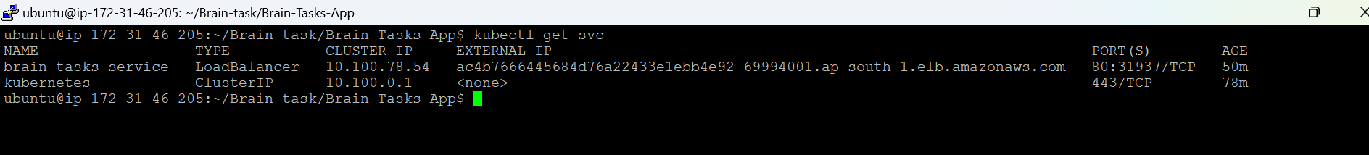

Project screenshots:
EKS cluster:
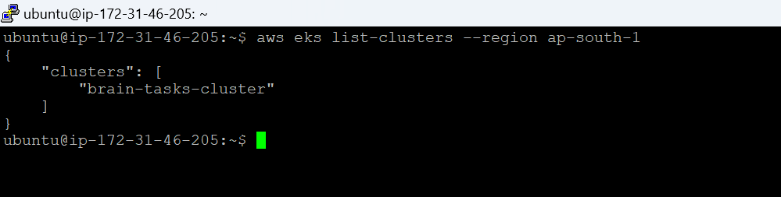
ECR Repo:
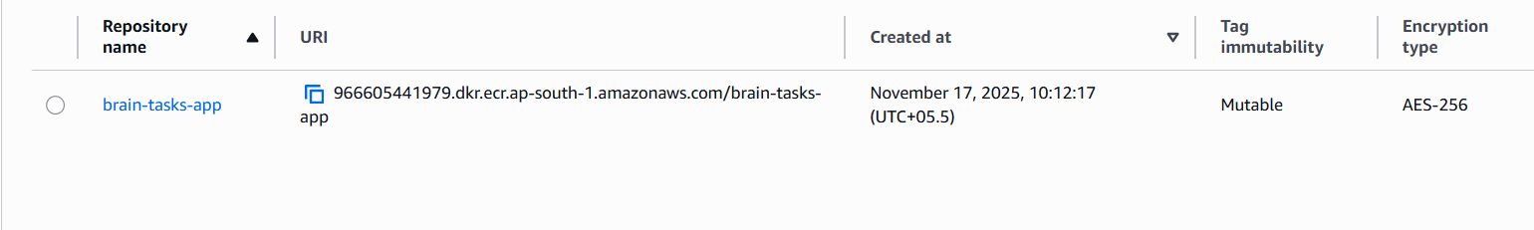
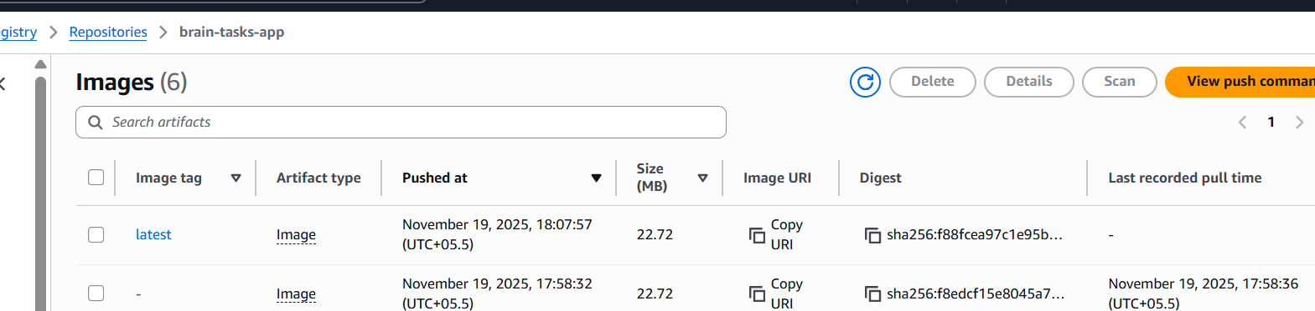
Code pipeline: deployed to EKS with codebuild, codedeploy required AWS plan upgrade and received mail from GUVI to ignore codedeploy.
